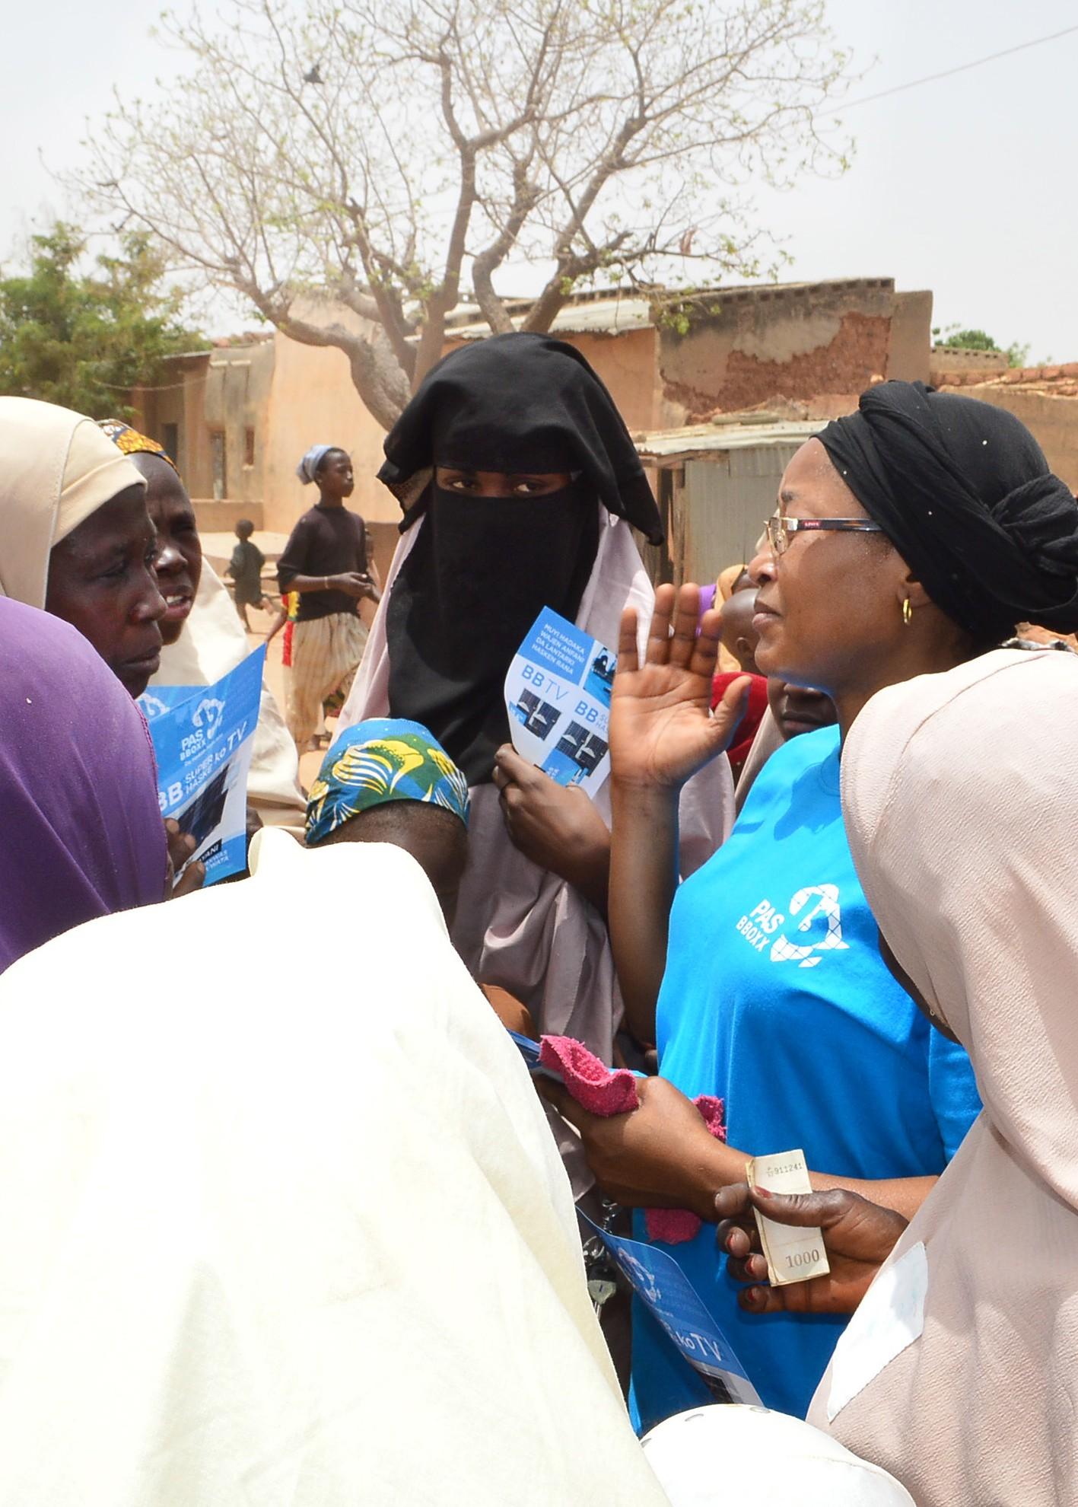
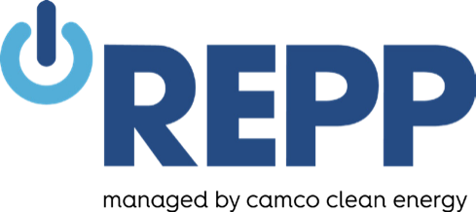

Table of contents

Introduction 3
Gender equality and REPP 4
How to use this toolkit 5
Definitions 6
Step 1: Gender analysis 7
Gender analysis at project level 7
Gender-sensitive stakeholder consultations 9
Gender mainstreaming in land acquisition 11
Gender analysis at the company level 12
Step 2: Gender action plan 14
Example of a partially completed gender action plan 17
Step 3: Monitoring and reporting 18

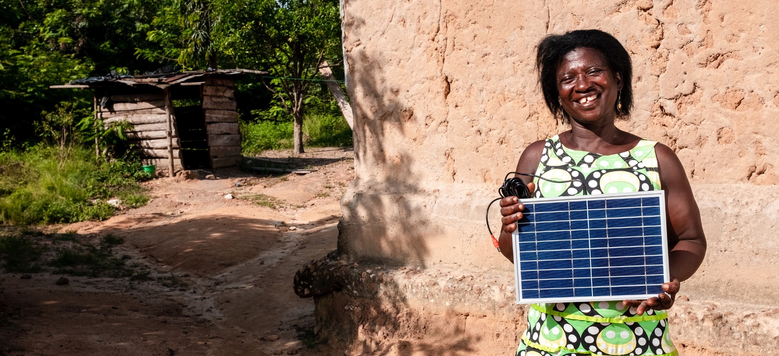
Introduction

REPP is working to stimulate the development of a vibrant, networked and viable market for small and distributed renewable energy projects in African countries in order to contribute towards Sustainable Development Goal (SDG) 7 – ensuring access to affordable, reliable, sustainable and modern energy for all, and SDG 13 – taking urgent action to combat climate change and its impacts.
Although the full and equal participation of women in decision-making and leadership in both the public and private sphere is a fundamental right in and of itself, it is particularly crucial to addressing the climate change and energy challenge.
Gender equality and women’s empowerment are integral to just and equal societies and have been widely recognised as important global objectives for several decades, including in the Sustainable Development Goals.
There is considerable evidence and broad international agreement that advancing gender equality works towards reducing poverty, supports inclusive growth and other wide-ranging development outcomes, and enhances the effectiveness and sustainability of development initiatives.

Women in African countries are key to energy production and consumption. Across rural communities in particular, women and girls are the primary energy producers in the household, meaning that they are responsible for sourcing fuel, paying for it and managing its use. Access to modern energy and appropriate appliances can therefore have a transformative impact on people’s lives, particularly women, by reducing drudgery and saving time. Furthermore, provision of a reliable affordable and convenient electricity supply contributes to support poor people typically living in remote rural regions.

Renewable energy companies that incorporate the needs and interests of women into their business plans, therefore, can expect to better serve their target energy market. Gender equality also makes profound business sense, since involving women and other marginalised people in energy-system supply chains leads to increases in productivity, organisational effectiveness, return on investment and higher consumer satisfaction. Projects that are “gender-blind” may further perpetuate existing inequalities and prevent marginalised members of societies from benefitting from access to sustainable energy.

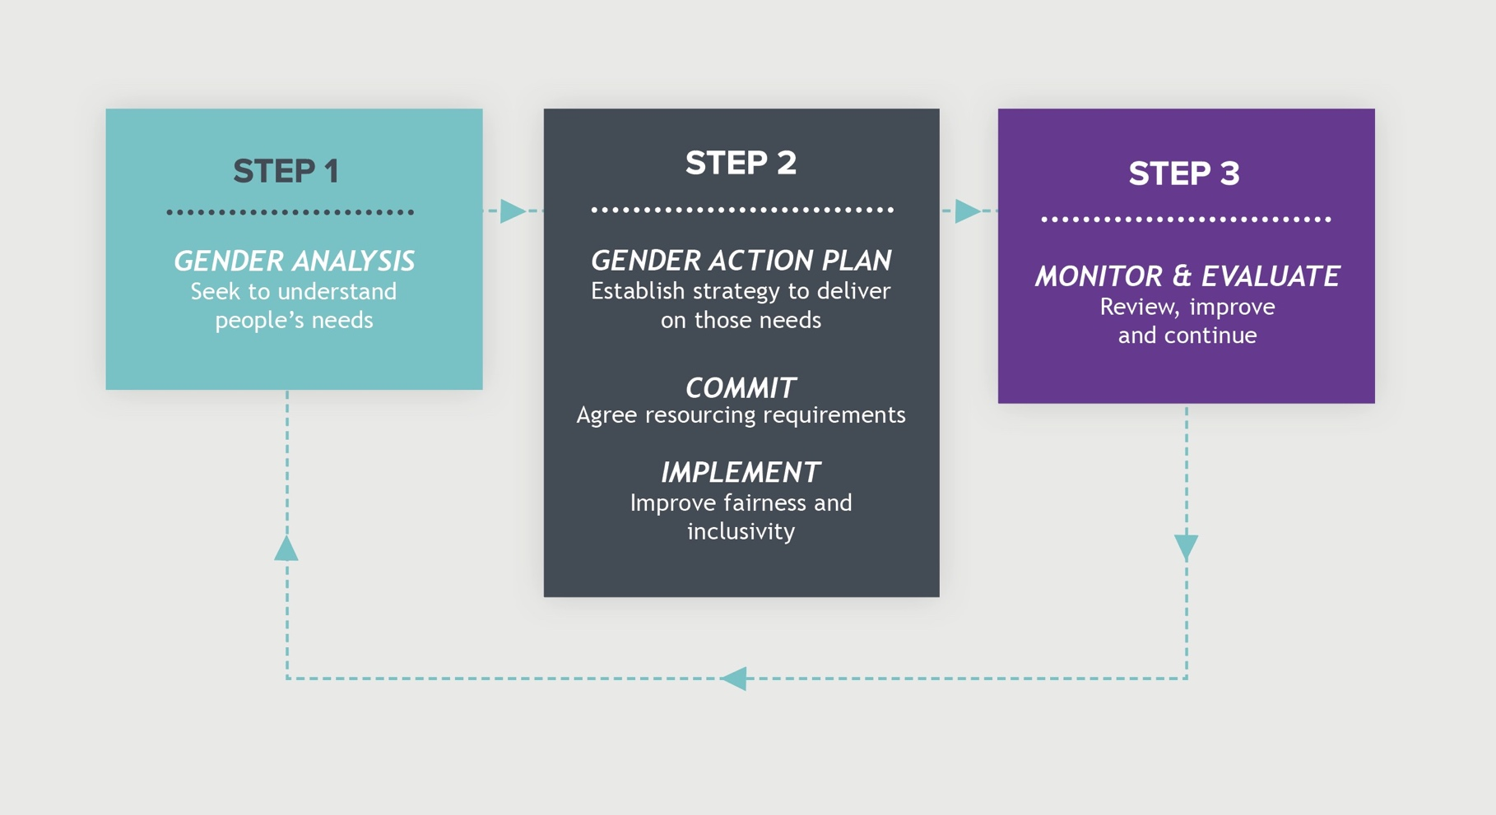
Gender equality and REPP
GENDER ANALYSIS GENDER ACTION PLAN MONITOR & EVALUATE
Seek to understand Establish strategy to deliver
people’s needs on those needs Review, improve and continue

COMMIT
Agree resourcing requirements

IMPLEMENT
Improve fairness and inclusivity
Figure 1: Process of gender mainstreaming

All REPP-supported projects must follow REPP’s Environmental and Social Policy, which is based on the IFC Performance Standards on Environmental and Social Sustainability and the EIB Environmental and Social Standards No. 3 and No. 10. IFC Performance Standards require projects to:

- Identify individuals and groups that may be directly or disproportionately affected by the project because of their disadvantaged or vulnerable status. Factors such as gender, age, ethnicity, culture, literacy or economic disadvantage, and dependence on unique natural resources should be considered.

- Ensure gender-inclusive consultation is implemented to provide the full picture of stakeholder perspectives. Experience shows that men and women often have different priorities, different energy needs, different perspectives on key issues, and may be impacted differently by a project or
programme. A gender-responsive project aims to tackle gender stereotypes that maintain the exclusion of women.

- Provide equal opportunities and fair treatment with respect to any aspects of the employment relationship.

Furthermore, REPP encourages all investee companies to promote gender mainstreaming in accordance with REPP’s Gender Mainstreaming Policy by:

- Analysing the gender equality situation within their own company, country of operation and project; and,

- Establishing an investee-specific gender action plan by identifying gender performance indicators and sex-disaggregated targets against an established baseline that can be incorporated into a monitoring plan.

How to use this toolkit

The purpose of this document is to help REPP investees integrate a gender equality perspective into the design, implementation, monitoring and assessment of their projects. It is designed to serve as a tool to establish a gender baseline and gender action plan for investees and their projects.

Investees can use the document to establish their gender baseline and gender action plan by filling in the form fields. Alternatively, it may be used as a reference only.

References

This toolkit has been drafted based on the following guidelines:

- Asian Development Bank (2013). Toolkit on Gender Equality Results and Indicators.

- Energia (2020). Why energy access and gender equality are inextricably linked.

- Giovarelli et al. 2005. Gender Issues and Best Practices in Land Administration Projects: A Synthesis Report. Prepared for World Bank.

- Green Climate Fund (2017). Mainstreaming Gender in Green Climate Fund Projects.

- UN Global Compact (online tool). Women’s Empowerment Principles Gender Gap Analysis Tool.

- International Finance Cooperation (2007). Stakeholder Engagement:
A Good Practice Handbook for Companies Doing Business in Emerging Markets.

- Virginie Le Masson (2019). Gender mainstreaming presentation on REPP’s Gender Considerations in the Stakeholder Engagement Process webinar.

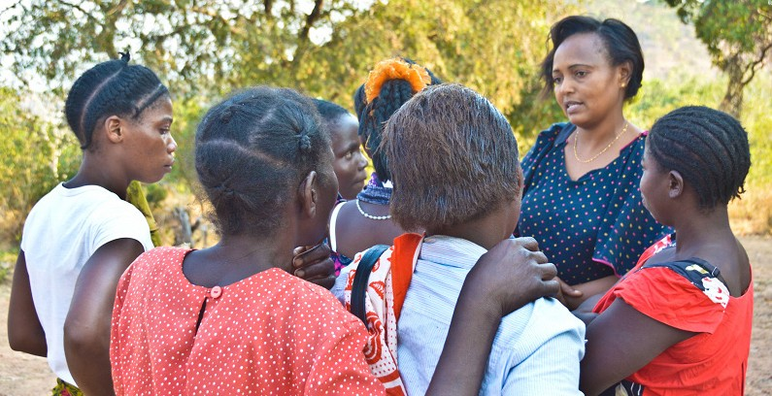

Definitions

Gender refers to the social differences, roles and expectations accorded to women and men. These roles are learned, can change over time and are influenced by culture, education, class, economic and political environments, the media, crisis and conflicts.
Gender equality refers to the equal rights, responsibilities and opportunities of women, men, girls and boys. Equality between men and women is seen both as a human rights issue and as a precondition for, and an indicator of, sustainable development.
Gender equity refers to the process to achieve gender equality. It often requires differential treatment of women and men (or specific measures) in order to compensate for the historical and social disadvantages that prevent women and men from sharing a level playing field.
Gender analysis is an examination of the status of gender equality in a country / targeted sector / company / project. At a project level, it highlights potentially relevant gender issues and gender-sensitive development impact opportunities, typically presented in the form of a gender baseline.
Gender assessment is based on the results of the gender analysis and describes the issues, gaps and problems that should be addressed by a gender-responsive action plan.
Gender mainstreaming refers to the process of adopting methods and tools throughout the project cycle that are necessary to promote gender equality and reduce gender disparities in project implementation.

Gender analysis

Gender analysis helps to identify existing gender inequalities and gaps in relation to a project and / or investee, as well as specific initiatives needed to empower women and remove barriers to equality.

Gender analysis should inform project design and therefore be undertaken in parallel with the establishment of an Environmental and Social Management System (ESMS). Specifically, gender analysis should:

- Identify and examine gender-specific risks relevant to the project and investee; and,

- assess the results of any consultations on the project and its objectives that have previously been carried out with relevant stakeholders – including women, girls, men and boys in the project area, gender advocates and women’s civil society organisations, and local and national authorities.

Investees should report the findings of project and investee-specific analyses internally, as well as to REPP and other relevant external stakeholders.

Gender analysis at project level

The following questions are designed to help you to identify and analyse gender-specific project risks, and intended outcomes. Use your answers to help describe the issues, gaps and problems identified, as well as possible opportunities.

Gender analyses should form part of the Environmental and Social Impact Assessment to influence project design, and where relevant be part of marketing analysis and the customer interaction process.

What is the context?
- What demographic data, disaggregated by gender and age in the project area, is available? (e.g. life expectancy, literacy, child mortality, percentage of woman-headed households, poverty level)
- What are the main sources of livelihoods and income for women and men?
- What impacts, negative or positive, will the project have on men and women? How are they different?
- What is the legal status of women in relation to the project (e.g. access to land or purchase power of electricity)? Is it different to men’s?
- What are the common beliefs, values and stereotypes related to gender in the affected communities?
- Could gender relations (i.e. the interactions, rights and responsibilities of men and women in relation to one another) have an impact on the effectiveness and sustainability of the project, activity or result?
- What inequalities and discriminations exist within the context of the project, and are certain people’s rights being denied?

[Record your observations and data collected here, including identified risks and opportunities.]

Who has what?
- What are the levels of income and wages for women and men?
- What are the levels of educational attainment for girls and boys?
- Describe the situation regarding land tenure and resource use. Who controls access to or owns the land?
- Do women have rights to land, and other productive resources and assets?
- What proportion of men and women have bank accounts? Have they received loans/credit?
- What proportion of men and women have mobile phones, access to radio, newspapers, TV?
- Do women and men have access to extension services, training programmes, etc.?

[Record your observations and data collected here, including identified risks and opportunities.]

Who does what?
- What is the division of labour between men and women, young and old, in their daily life and how could this affect their involvement in the project?
- Who manages the household and takes care of children and/or the elderly?
- How much time do women and girls spend on domestic and care work tasks compared with men and boys?
- How do men and women participate in the formal and informal economy?

[Record your observations and data collected here, including identified risks and opportunities.]

Who decides?
- Who controls/manages/makes decisions about household resources, assets and finances?
- Do women have a share in household decision-making?
- What are the main areas of household spending?
- How are men/women involved in community decision-making? Are local leaders supportive of women’s rights?
- Are there women’s associations active in the area that would support consultation processes and dialogue with different members of communities?
[Record your observations and data collected here, including identified risks and opportunities.]

Who benefits?
- Does the project directly respond to needs expressed by local people in the area of intervention?
- Is the project likely to benefit only a particular category of people? (e.g. urban dwellers? men working in certain sectors? school children?) Where are those who will benefit?
- Are men’s and women’s needs and priorities in the area of intervention different?
- How will the proposed results - services/products - affect the relative status of women and men?
- Will the project exacerbate or reduce inequalities? If yes, how?
- Will the proposed interventions cause an increase/decrease in women’s (and men’s) workloads? If yes, how?
- How will the proposed interventions increase the incomes of men and women, respectively?
- Could the project benefit everyone in the area of intervention?

[Record your observations and data collected here, including identified risks and opportunities.]

Gender-sensitive stakeholder consultations

Good practice considerations

Gender-sensitive stakeholder consultations are essential for understanding all stakeholder perspectives. Local customs and traditional roles may suppress women’s voices. Good practice includes actively seeking out the views of women, which provides companies with a more complete picture of potential risks, impacts, and opportunities relating to their project. See Figure 2 for other good practice principles.

Gender-inclusive consultations can be promoted by:

  - Active facilitation techniques to encourage women’s participation in public meetings or workshops. Techniques include working in smaller and/or single-sex groups; asking specifically “What do the women in the room think about this issue?”; using games, drama or drawing to increase women’s level of comfort and contribution; and organising separate meetings specifically for women.

  - Disaggregation of data by gender to better understand gender differences related to the project.

  - Representative samples by gender in surveys and interviews to gather women’s views of project- related issues, including female-headed households.

  - Active participation of women in running surveys and community liaisons to encourage female participants to express their views and concerns.

- Ensuring gender-awareness of the whole team so that everyone appreciates the benefits of understanding the views of both men and women.

- Facilitation and encouragement of women’s participation in consultation events. For example, by providing childcare; choosing a time of day, date, and location convenient for women; asking networks with predominantly female membership to encourage their members to participate; and providing transportation to and from the meeting venue. Further factors such as illiteracy and education level should be considered when selecting suitable facilitation methods. Have a plan for communicating the importance of gender issues that addresses different target audiences with
appropriate messages and formats (consider differing levels of literacy, language, and access to media).

- Recognition that women are not a homogeneous group, and thereby providing adequate attention to ensure the representation of different perspectives across socioeconomic, caste, ethnic, and religious lines. Marital status and age are also important factors.

Note: Remember to keep minutes and other relevant documentation of stakeholder meetings and distribute them to participants after the meeting. In case of formal meetings, the minutes should be agreed and signed by the relevant stakeholders.

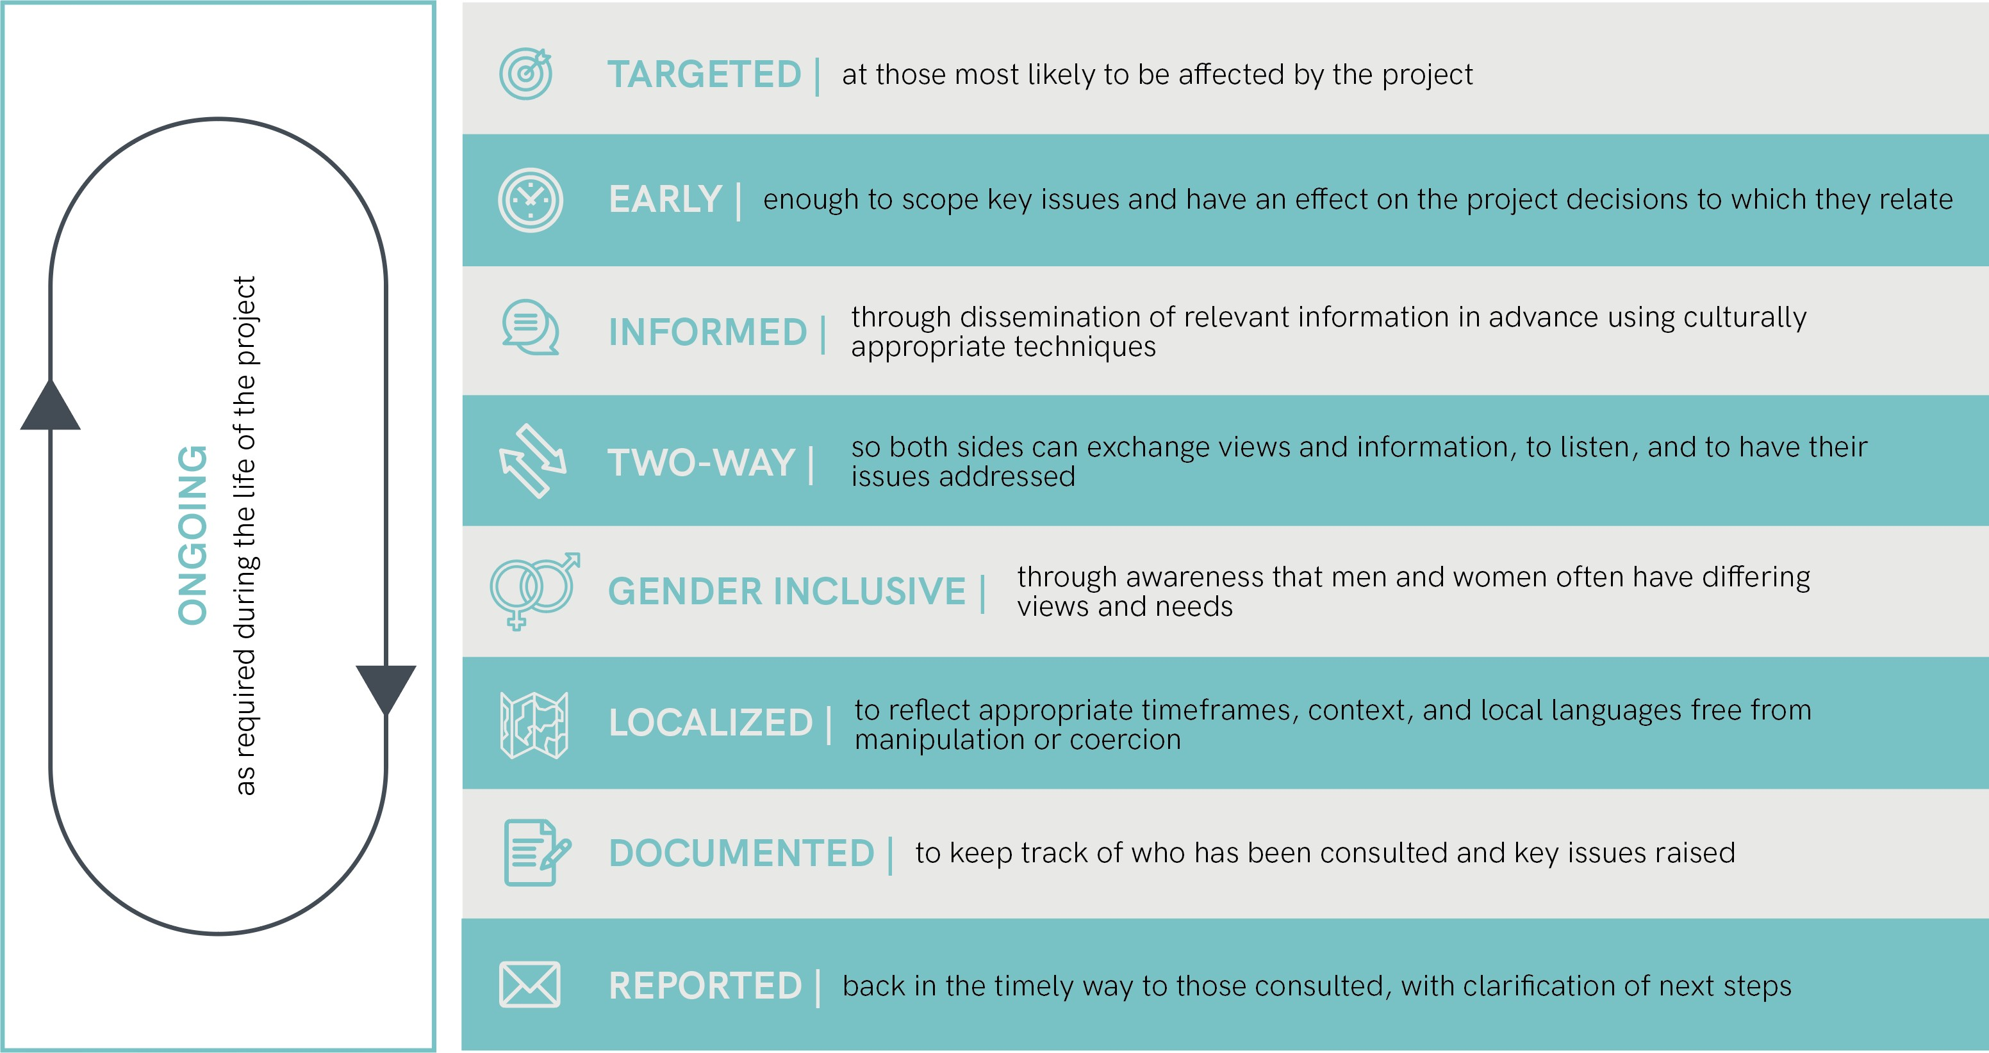

Figure 2. Basic principles of good practice for stakeholder consultation (Adapted from: IFC 2007)

[Describe how you conducted your gender-sensitive stakeholder consultation here.]

Gender mainstreaming in land acquisition

Good practice considerations

The rights of women regarding landownership and management in Africa vary drastically based on the cultural and historical context of the region and their marital status. Lack of information can lead to projects that limit or reduce women’s economic and social opportunities. The best way to ensure sustainable gender mainstreaming in land acquisition is through training, education and awareness raising.
The points below offer some considerations for good practice. They should not be considered as all- encompassing guidance, and are not intended as a substitute for specialist guidance.

- Land acquisition is one area of activity where gender-responsive community engagement is particularly important.
- In the planning stage, undertake legal and qualitative research of related laws and customs that affect women’s property rights to understand how the land acquisition will affect women in the project community.
- Seek out women’s input - including women who are knowledgeable about property rights and family law – on the impact of the land acquisition.

- Consider who has what rights in the bundle of rights associated with land.
- Provide training to ensure project staff, community leaders, and project beneficiaries have the relevant information about the formal and informal laws surrounding land acquisition.
- Allow for separate, women-oriented stakeholder engagement and consultation sessions to create a conducive and unbiased environment.

- Use local expertise in project communication and community training. Regional NGOs, local government, and universities often have local-level resources and an understanding of local cultures and traditions.

- When scheduling meetings and other consultation activities, give careful consideration to people’s work and domestic duties to maximise potential attendance.
- Offer flexibility where people are not able to provide required documentation. Identity cards, for example, can be difficult to obtain for women, especially in rural areas.
- Assist women in establishing community organisations or seeking support from established organisations focused on women’s and girls’ needs and interests (e.g. access to microcredit, education and training, or development of industries desired by women).
- In cases of disputes try to resolve issues locally to the extent possible. Consider that women may have rights under formal law for dispute resolution, but either do not have the knowledge or the financial means to pursue their rights through the courts.
- Respect local culture, custom, and religion and keep in mind regional differences.

Furthermore, it should be noted that local customs may deny access to land tenure for women. Therefore, involving local women’s organisations is of crucial importance.
The specific content of the community training, referred above, will vary depending on the project and its location. All the following points, however, should be considered in training women and men:

- Legal rights of women on land, including inheritance and divorce;
- Special problems encountered by women (for example, documentation or access to credit);
- The involvement of women and men in the adjudication process and in registration of rights;
- Benefits of participation.

Gender analysis at the company level

The following questions are designed to assist you in carrying out gender analysis at the company level, and to identify and analyse gender-specific risks. Use your answers to help describe the issues, gaps and problems identified.
Companies are also advised to make use of the Gender Gap Analysis Tool, which is based on the questions.
Workshops and (anonymous) questionnaires provide useful ways to gather and record employees’ views an inputs for gender gap analysis. On completion of the analysis, present the key concepts and learnings to all employees.

Areas of review

Policy frameworks
- Does your company have leadership commitment and support for gender equality and women’s empowerment?
- Does your company have a non-discrimination and equal opportunity policy, either stand-alone or clearly included in a broader corporate policy?

[Summarise your company’s approach to gender policy here, specifying any issues, gaps and problems.]

Identify existing gender capacity

- Has a gender representative been appointed within you company?
- Has training / capacity building needs of staff and stakeholders been considered / taken place?
- Does your company have policies and processes in place to ensure responsibility for respecting the rights of women and girls in the local communities in which it operates?
- Does your company take proactive procurement steps to expand relationships with women-owned businesses in the value chain and when contracting vendors?
- Does your company encourage suppliers and vendors to advance performance on gender equality?
- Does your company have an approach to assess differential impacts on women and men when developing products and/or services?

[Summarise your company’s existing gender capacity here, specifying any issues, gaps and problems.]

Gender-conscious workplace

Does your company:

- Have an approach to ensure non-discrimination and equal opportunity in recruitment processes?
- Have an approach to ensure non-discrimination and equal opportunity in professional development and promotion processes?
- Offer and support paid maternity leave?
- Offer and support paid paternity leave? Is the extent of paternity leave the same as maternity leave?
- Have an approach to support employees as parents and caregivers?
- Have an approach to accommodate the work/life balance of all employees?
- Have an approach to ensure an environment free of violence, harassment and sexual exploitation?
- Have an approach to address the specific health, safety and hygiene needs of women at work and while commuting to work?
- Have an approach to promote access to quality health services that meet the specific health needs of women employees, as well as employees with diverse gender identities?

[Summarise how gender-conscious the workplace is at your company here, specifying any issues, gaps and problems.]

Gender balance of staff
- Does your company have gender balance at management level? If not, do you have a strategy to achieve that?
- Does your company have gender balance across the rest of the company?

[Summarise the gender balance of staff at your company here, specifying any issues, gaps and problems.]

Payment gap
- Does your company have an approach to ensure women and men are compensated equally?
- Do aspects of pay, such as salaries and bonuses, differ by gender?

[Summarise the payment gap situation at your company here, specifying any issues and problems.]

Gender action plan

Companies need to establish a gender action plan to overcome the constraints and negative impacts identified during the gender analysis, as well as maximise the benefits and opportunities identified. The plan should establish ambitious, but realistic targets.

Through this process, gender mainstreaming must be made an integral part of the project across all stages, starting from the beginning. Gender programmes and actions should be cross-cutting to all aspects of project development and everyone’s responsibility within the company – not only women.

This means all staff, including foreign technical assistants working on the project and senior management, are involved in gender mainstreaming and have gender-equity awareness so they can act as role models both to colleagues and outside of the company.

The gender action plan should:

- Distinguish between company-level actions and project-level actions. Tip: the templates included later in this section provide a version for each.
- Include objectives and gender-responsive actions that address and strengthen the voice and agency of marginalised groups and promote equity.
- Identify risks for not achieving the objectives.
- Include gender performance indicators and gender-disaggregated targets to monitor if and when objectives are achieved.
- Provide a timeline for achieving targets.
Promoting gender equality is a long-term commitment. Therefore, consider the need for project-related targets, i.e. those which can be achieved within the duration of the project, and longer-term outcomes that the project can contribute towards even though the results might occur after the project is completed. For the latter, consider identifying intermediate targets which the projects can report against, while indicating that longer-term objectives are more ambitious. For instance, the project might aim to have an equal number of men and women offered an engineering position related to the implementation of activities. However, the gender analysis revealed that women are less likely to have an engineering qualification than men in the area of intervention. The gender action plan, therefore, could suggest gender-responsive targets within the duration of the projects such as:

  - gender-responsive procurement process (i.e. that do not discriminate against women and actively encourage their application by using gender neutral terms or indicating how the employer supports flexible working hours);

  - at least 50% of women shortlisted for interviews.

And, intermediate targets which will serve longer-term results, such as:

  - establish a partnership with a local university to offer scholarships to women studying engineering.

- Establish a budget that translates equality objectives into fiscal commitments.

Guidance on good practice

Objectives and gender-responsive actions should be derived from the issues and risks identified during the gender analysis.

Gender performance indicators should be used to measure the following:

- Differences in participation, benefits, outcomes, and impacts for women, men, boys, and girls;

- Changes in gender relations, which includes changes toward equality, between men and women, and between girls and boys; and,

- How these changes impact on the achievement of development objectives, particularly economic growth, poverty reduction, and sustainable development.

Follow these helpful tips for choosing good indicators: choose a good indicator:

- Valid: measuring what the indicator is intended to measure.

- Specific: measuring only the particular aspect of the initiative it is intended to measure.

- Reliable: minimising random error; and producing the same result consistently, given the same set of circumstances, including the same observer or respondent.

- Comparable: enabling comparisons of results or effectiveness over time, and in different contexts.

- Precise: using clear, well-specified definitions.

- Relevant: clearly linked to an input, output, or outcome of the project or initiative being measured.

- Verifiable: able to be proven or tested empirically

Consider the following when establishing a budget:

- Ensure sufficient resources, both people and funds, are available for advancing gender equality and women’s empowerment activities.

- What expenditures can be allocated to social inclusion of the total budget?

- What are the assumptions informing budgets?

- Who makes decisions / whose influence is denied?

- Consider potential reports, workshops, training events, travel etc. that are required at project and company level.

Create your gender action plan using the template provided below. Add more rows if necessary. Hover over the border of the rows to the left of the table.

COMPANY-LEVEL GENDER ACTION PLAN

OBJECTIVE | ACTION | INDICATORS | TARGETS | TIMELINE | RESPONSIBILITIES | COSTS
[add objective] | [specify action(s)] | [specify indicator(s)] | [specify target(s)] | [specify timeline] | [specify responsibilities] | [specify costs]

PROJECT-LEVEL GENDER ACTION PLAN

OBJECTIVE | ACTION | INDICATORS | TARGETS | TIMELINE | RESPONSIBILITIES | COSTS
[add objective] | [specify action(s)] | [specify indicator(s)] | [specify target(s)] | [specify timeline] | [specify responsibilities] | [specify costs]

Example of a partially completed gender action plan

OBJECTIVE | ACTION | INDICATORS | TARGETS | TIMELINE | RESPONSIBILITIES | COSTS
Example 1: Gender balanced employment | Contract women in civil works, financial and customer services, and as female engineers.  Require contractors to employ local labour, including women, as appropriate. | Number of women and men employed through jobs created from the project in each job category (person-days).  Number of women and men shortlisted for job interviews in each job category. | 30 women;  40 men.  45% female candidates;  55% male candidates. | dd/mm/yyyy  dd/mm/yyyy | Operations Manager  HR Manager | USD: Would be defined based on extra effort invested in job advertising, recruitment process, ensuring women’s  safety and facilities for female  on site.
Example 2: Improved access to affordable electricity | Consult women during stakeholder engagement to ensure their needs are met in the product offering;  Inform women on the service offering and requirements;  Encourage women to apply for financing. | Number of households and individuals, males and females, with improved access to renewable energy source. | Arrange two community consultations specific to women;  40% of customers by 2022 to be women. | dd/mm/yyyy | Community Liaison  Officer | USD: Would be defined based on extra community meetings and marketing efforts that need to be arranged.
Example 3: Equal pay for equal work | Undertake payment gap analysis of all staff and identify:  - raw gap (average female salary vs male salary),  - gap by position (compare like–for-like position between men and women),  - gap by age (categorise employees by age and compare difference by gender);  - gap by education level and experience. | Annual gender pay gap analysis. | Narrow gap to 10% by 2021;  0% pay gap by 2023. | dd/mm/yyyy  dd/mm/yyyy | Management team, HR Manager | USD: Would be defined based on hours spent on analysing data and required budget to narrow gap based on results.
 | Present results to employees; Readjust salaries where relevant; Commit to equal pay for equal work in company HR policy
[Delete this section after you have established your own gender action plan]

Monitoring and reporting

Consider the following when monitoring the implementation of the gender action plan and a project’s gender performance:

- Were activities and processes implemented as planned?
- Were objectives, outcomes, or other types of results achieved - i.e. was a change achieved or any other progress made?
- Were there any unintended impacts, results, or consequences? If yes, explain how, by whom and what actions will be taken to address them.

Guidance on good practice

Employ both qualitative and quantitative data collection methods.

Focus on quantitative gender equality indicators, which are numerical measurements of change, as these are easier to measure and assess against targets.

Qualitative gender equality indicators such as perceptions or attitudes - and how these change
- can also be applied to capture change that is difficult to measure. Qualitative indicators may also focus on description and analysis of certain types of change, such as gender analysis of the content of training programs, or assessments of organisational capacity.

Key considerations:

  - Has baseline data been collected to enable the measurement of project outcomes/outputs?
  - Have gender-specific targets been established for women and men in terms of benefits and participation?
  - Has the collection of sex-disaggregated data been carried out throughout the monitoring chain?
  - Do progress reports and implementation status reports discuss gender equality results and lessons learned?
  - Ensure that the team involved in monitoring is gender-sensitive and gender-balanced, with adequate gender expertise;
  - Use gender-sensitive data collection techniques, such as separate focus / interview groups for women and men, depending on the context.
  - Are you monitoring barriers to participation in project activities?
  - Capture qualitative lessons learned and best practices through narrative reporting;
  - Ensure gender-related questions are mainstreamed into monitoring and evaluating plans and reporting.

[Describe indicators monitored, monitoring frequency and date collection methods here.]

+44 (0)207 121 6101 | info@camco.energy

Camco Management Limited. Company number 09902551 Registered address: 20 Jerusalem Passage, London EC1V 4JP, United Kingdom.

Camco Management Limited is an Appointed Representative of Mirabella Advisers LLP, whose FCA number is 72448.

